Dear Visitor, 10th January 2021

COVID-19 Lateral Flow Testing

We are pleased to announce that we have begun to provide testing for visitors to Mary Stevens Hospice. Regular testing of visitors can help to support more meaningful visits with loved ones, when combined with other infection prevention and control (IPC) measures (such as social distancing and the use of personal protective equipment).

Testing can support the Hospice to safely maintain a balance between infection control and the vital benefits of visiting to the health and wellbeing of your loved ones while they are in the Hospice. However, testing visitors does not completely remove the risk of spreading the coronavirus.

Mary Stevens Hospice intends to start testing visitors from Monday 11th January 2021. We will also be introducing a booking system for visits to ensure not everyone turns up at the same time to be tested. Tests will be taking place in the Lodge (the first building on the left-hand side as you leave the main road to come onto the Hospice site) and you will be asked to report to that building before entering the Hospice. You can park in the rear car park and then proceed to the lodge, which is the building circled below:

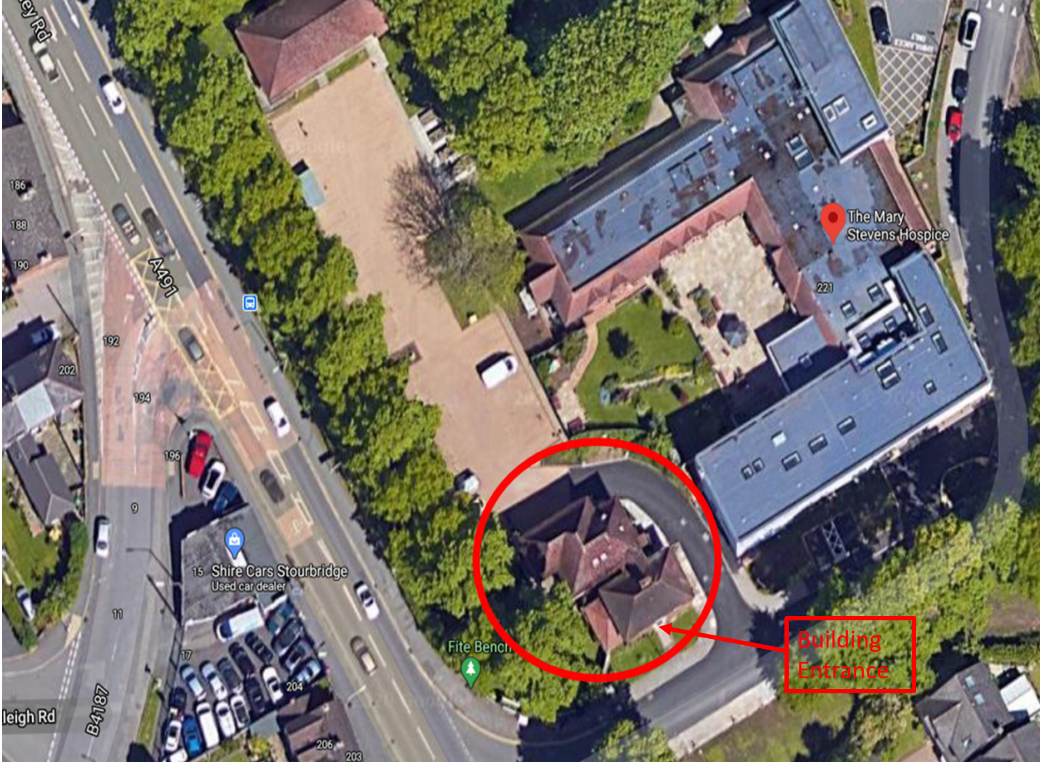

The Government have provided information for visitors to care homes so they know what to expect when they complete an LFD Test, this visitor testing guidance pack is the same for when you visit the Hospice. Please read the pack carefully before scheduling a visit so that you know what to expect before, during and after your visit.

Testing is really important to help us to identify people who might be carrying coronavirus but not showing symptoms. Testing may not identify everyone that is currently infectious, but alongside other infection prevention and control measures and wearing PPE, testing helps us to keep Mary Stevens Hospice and your loved ones safe.

We are providing you with a link to the visitor guidance pack from the Department of Health and Social Care (DHSC), so you know what to expect when you come for your visits. We hope that you’ll agree with us that the 30-minute testing process is a minor inconvenience to support us in managing the risks of coronavirus, and the chance to have closer contact with your loved one.

If you have a valid reason for not wanting to take a test, please do discuss this with us at the very earliest opportunity. Without testing, indoor visits may still be possible when we are back to being in a Tier 1 area, but now we are in Tier 4 it really is an essential measure to protect your loved ones, you, our staff and other patients and visitors.

We would not expect you to take a test every day but would expect you to do so every 4th day. So, if you were tested on a Monday for your first visit, we would then test you again on the Thursday and then the again the following Monday.

If you have a smartphone, please bring this with you, as you will then be able to register your own test and the result with the NHS.

If you have any further questions or queries about visiting loved ones at the Hospice, please speak to one of the nursing staff.

Thank you in advance for your patience and cooperation. We'll continue to work hard to support and improve meaningful visits with your loved ones.

Yours sincerely

Original Signed

Claire Towns
Chief Executive Officer & Matron

